Da: **Erasmus Office UNI** <[erasmus@universum-ks.org](mailto:erasmus@universum-ks.org)>  
Date: ven 6 ott 2023 alle ore 09:01  
Subject: Open Call for Job Shadowing | UNI-Universum International College, Kosovo  
To:   
Cc: Gentiana Berisha <[gentianaberisha@universum-ks.org](mailto:gentianaberisha@universum-ks.org)>

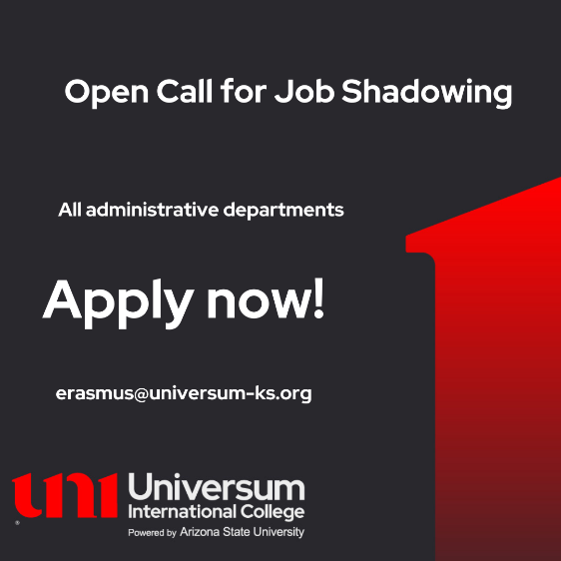

Dear partners,

I hope this email finds you well.

We are delighted to announce an open call for **job shadowing** opportunities at [UNI - Universum Interantional College](https://universum-ks.org/" \t "_blank), specifically designed for administrative (or academic) staff members from our esteemed partner universities. This initiative is made possible under the Erasmus+ Staff Mobility program, reflecting our commitment to promoting international collaboration and professional development in higher education administration.

**Available Departments for Job Shadowing:**

* HR Office
* It Support
* Marketing and Communication
* Admission, Student Support
* Career Office
* Alumni Office
* International Office
* Project Office
* Quality Assurance Office
* Student Success Center
* Student Wellbeing Center
* Study Programs Administrator

**Eligibility Criteria:**

* Participants must be currently employed as administrative staff (or academic) members at one of our partner universities.
* Proficiency in English is required
* Commitment to actively engage in the job shadowing experience and share acquired knowledge.

**Application:** All individuals intrested in applying are kindly requested to complete this [FORM.](https://forms.gle/VYZdKKh2W5PVNAxC7)

Applicants have the freedom to select their preferred mobility dates within the academic year 23/24, including holidays and summer break.

**Benefits:**

* Gain firsthand experience in international higher education administation.
* Networking opportunities with professionals from diverse backgrounds.
* Develop a deeper understanding of the Erasmus+ program and its impact on international education.
* Social and cultural activities in Kosovo.

We are excited about the prospect of welcoming administrative staff members from our partner universities and facilitating a meaningful exchange of knowledge and experiences.

If you have any questions or require further information, please do not hesitate to contact us.

Warm regards,

**Erasmus + Mobility Office**



Address: Prishtine-Ferizaj highway, km 12, 10000

Pristina / Kosovo

**Tel:** +383 44 144 062

**Email:** [erasmus@universum-ks.org](mailto:erasmus@universum-ks.org)

**Web:** [www.universum-ks.org](http://www.universum-ks.org/)