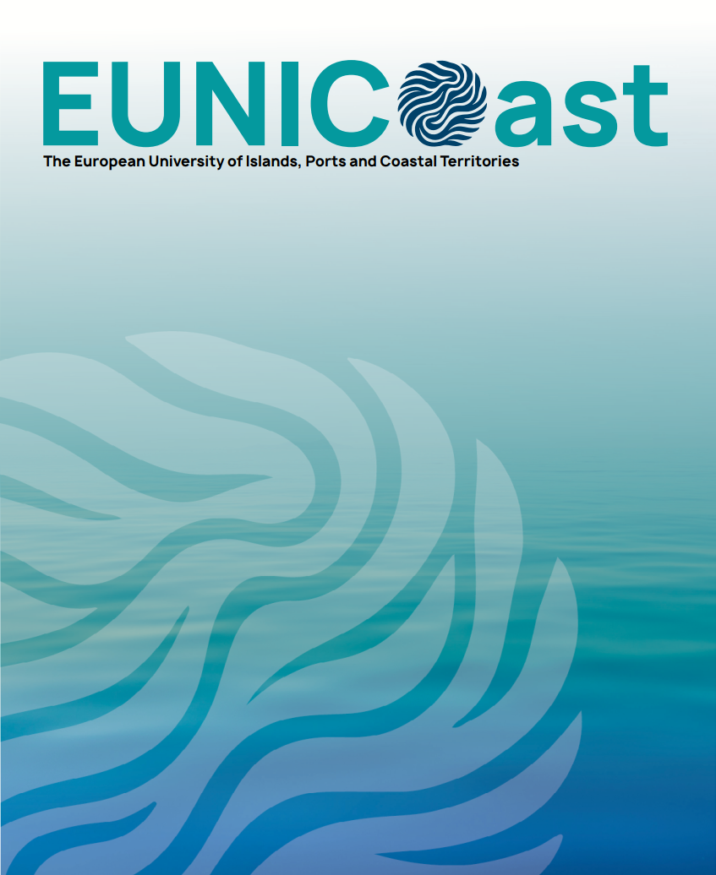

Title (3 ECTS)

- General Information

Course Title
Coordinating institution
University of Sassari (UNISS)
Partner institutions involved
Main lecturer (s)
Contact Person
Name: | Phone Number | E-mail:
Language(s) of instruction
ECTS Credits
ECTS
Type of course
Blended Intensive Programme – BIP
Delivery Format
Virtual and physical
Study level
Target Disciplines
Required Language Proficiency
Minimum B_ in ___ according to the Common European Framework of Reference for Languages (CEFR)

- Alignment with the EUNICoast Educational Model

Brief explanation of how this course aligns with EUNICoast's mission and educational values:
Which of the five EUNICoast focus areas does the course contribute to? (Select all that apply)
☐ Identities, Local Knowledge, and Cultural Heritage in Islands & Coastal Communities
☐ Blue Circular Economy, Port Logistics, and Sustainable Blue Tourism
☐ Governance, Planning, Management, and Monitoring of Islands and Coastal Communities
☐ Health, Biodiversity Protection, Nature-based Solutions, and Sustainable Exploration of Coastal/Marine Resources
☐ Engineered and Data-driven Solutions for Coastal Infrastructures, Marine Renewable Energy, Marine Safety, and Navigation Systems

Which of the six major challenges of the alliance does the course address? (Select all that apply)
☐ Climate change and environmental degradation
☐ Economic diversification in peripheral territories
☐ Biodiversity conservation (marine and terrestrial)
☐ Sustainable infrastructure and health system development
☐ Social cohesion and migration challenges in island contexts
☐ Talent and population retention in islands and coastal areas

- EUNICoast Competency Framework and Learning Outcomes

Relevant EUNICoast Competency Domains

Select the transversal competencies that the course aims to develop (check all that apply):
☐ Sustainability literacy (e.g., Understanding sustainability challenges in coastal regions, applying nature-based solutions)
☐Digital competence (e.g., Using GIS, digital collaboration platforms, responsible use of AI)
☐ Intercultural competence (e.g., Working effectively in multilingual teams, adapting communication across cultures)
☐ Civic and social engagement (e.g., Designing community-based projects)
☐ Critical and solution-oriented thinking (e.g., Framing complex problems)
☐ Entrepreneurship and innovation (e.g., creating environmental start-up ideas)
☐ Autonomous learning planning (e.g., using feedback for personal growth)
☐ Communication and collaboration (e.g., Writing project reports, presenting findings, working in diverse teams)

Intended Learning Outcomes (ILOs)

List 4–6 learning outcomes that reflect the selected competencies. Each outcome should be clear, measurable, and action-oriented.
- To grasp the fundamentals of energy and economic analysis and gain familiarity with applications and skills related to the management of protected areas, like the acquisition, processing and georeferencing of a variety of data (biophysical, economic, statistical).
- To calculate and interpret ecological and economic indicators at various spatial scales.
- To operate softwares that helps estimating the value of the underlying inputs.
- To fit into interdisciplinary professional teams such as those working on environmental issues.

- Course Content

Relevant EUNICoast Competency Domains

Provide a concise summary of the course, including its academic focus, main learning activities, and types of outputs or assessments expected.

Main modules or thematic blocks
List and briefly describe the course’s main content units. Indicate whether the module is theoretical, practical, or blended.

Virtual component (__ days):
Physical component – 5 days activities, including both lectures and practical activities (2 days at the Economics Department of UNISS and 3 days in the Asinara island, where the park staff will lead the group.

Indicative Weekly Schedule (optional)
Provide an overview of the course structure by week or day (if intensive). Include session types (lecture, workshop, fieldwork), and time allocations if available.

Days | Sessions | Main Topics / Activities | Format | Contact Hours | Independent Work | Total Hours
Virtual component (Dates)
Day 1
Day 2
Day 3
Day 4
Physical component (Dates)
Day 1
Day 2
Day 3
Day 4
Day 5

Total Workload
- Contact hours:
- Independent work:
- Overall workload: 75 hours = 3 ECTS

- Teaching and Learning Methods

Pedagogical Approach

Describe the overall teaching philosophy and learning strategies used in the course. Indicate how active, collaborative, or experiential learning is integrated.

Teaching and Learning Formats

Select and describe the formats that apply to your course (check all that apply):
☐Project-based or challenge-based learning
☐Lectures (in-person or online)
☐Interactive seminars
☐Group work / peer collaboration
☐Problem-based learning
☐Fieldwork or site visits
☐Co-design/co-creation with stakeholders
☐Online asynchronous activities (videos, discussion forums, quizzes)
☐Other (please specify):

Digital Tools and Platforms

Specify any tools or platforms used for teaching, collaboration, or assessment.

Mobility Component

Does the course include a mobility element?
☐Yes, physical mobility
☐ Yes, virtual mobility
☐ No
If yes, briefly describe the structure and added value of the mobility component.

- Evaluation Criteria

Assessment Component | Format | Weight | Competencies Assessed | Re-sit Allowed?

- Quality, Inclusion and Stakeholder Engagement
Explain how feedback will be collected and used to improve the course.
Describe how the course ensures accessibility for all learners, taking into account linguistic diversity, cultural sensitivity, and specific needs (e.g., physical, digital, learning support).
Indicate whether and how external stakeholders (e.g., local authorities, NGOs, businesses, civil society organisations, research institutions) are involved in the course design or delivery.
☐Stakeholders involved in course design. Parco Nazionale dell’Asinara is contributing to aligning course outcomes with labour market needs in the Blue Economy, Blue Tourism, and sustainability education.
☐Stakeholders involved in delivery. Parco Nazionale dell’Asinara participates by running the practical sessions, providing perspectives on island ecology and sustainability.
☐Stakeholders involved in assessment or review.

- Resources and Bibliography

Please list the core and optional resources students will need to engage meaningfully with the course content. Use recent, relevant, and preferably open-access materials where possible.
Core Readings / Materials
Supplementary Resources (Optional)

